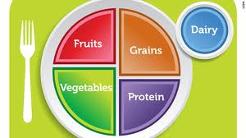**My Plate – Food Lab**

Name: Quang Huynh

Opp: 1

**DIRECTIONS**: Go to [www.choosemyplate.gov](http://www.choosemyplate.gov).

On the top, left side, GO TO:  **MyPlate**

**1. Click on the grain group.**

a. **What are some examples of foods in this group?** Oats, cornmeal, oats, bread, pasta, grits, and tortillas.

b. **What is the difference between refined/whole grains?** Refined grains are enriched. While whole grains contain the entire grain kernel.

c. **How much of your grains should come from whole grains?** At least half of the grains you eat should be whole grains.

d. Explain what enriched is, is it good for you? Enriched means that nutrients were added into the grains to make them more healthy. But, enriched foods are heavily processed and come with lots of salt, sugar and fat. So they might not be the best option.

**2. Go to the menu bar on left side. Click on vegetables.**

a. What are the five sub groups? Give an example from each group. The five sub-groups are dark green; red and orange; peas, beans and lentils; starchy; and other vegetables. An example of dark green would be broccoli. Then, red and orange could be a carrot. Next, black beans are another example of the beans, peas and lentils. Corn is a good example of starchy. Finally, beets can be an example of other vegetables.

b. How much dark green vegetables should a 16 year old girl consume in a day? 11/2 cups per week.

How much beans and peas for 16 year old boy? 2 cups per week.

c. What are two health benefits to eating foods from this group? Reduced risk of chronic diseases and vegetables provide important nutrients for the body.

d. Why are peas and beans a unique vegetable? They belong to two separate groups. They can be in the protein group and the vegetable group.

**3. Go back to the menu bar and click on fruit.**

a. How many cups per day is recommended for a 14–18 year old boy? 2 cups, girl 11/2 cups

b. What are two health benefits to eating foods from this group? Fruits provide the body with healthy important nutrients and can reduce the risk of chronic diseases.

c. Most fruits are naturally low in fat, sodium and calories. Fruits have none of this: (look under Nutrients)

Cholesterol

d. Fruits contain fiber. Explain what fiber is, what is does for the body and give 2 sources.

Fiber is important for proper bowel function. It reduces constipation and diverticulitis. Two sources of fiber can be fruits, whole or cut cup. While fruit juices have little to no fiber.

e. Name 2 tips to help you consume more fruit.

Some tips to consume more fruit would be to plan what you eat. Also, you can add more flavors to fruits while you eat them to enjoy them more.

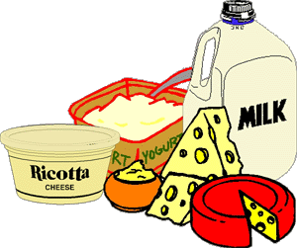

**4. Go back to the menu bar and click on Dairy.**

a. What are three sources of dairy? Three sources of dairy are milk, cheese and

yogurt.

b. How much should a teenager have each day? A teenager should have 3 cups of dairy per day.

c. What is the essential nutrient is found in dairy? The essential nutrient found in dairy is calcium.

d. Give two health benefits of this food group. Dairy helps with building and maintaining strong bones. Furthermore, they provide important nutrients for the body.

e. Name 3 non-dairy sources of calcium. Almonds, beans, soy milk.

**5. Go back to the menu bar and click on Protein.**

a. Name 3 different sources of protein? Three different sources of protein are meat and poultry, seafood and legumes.

b. How many ounces should a teenager have each day? Teenagers are supposed to have 5-61/2 ounces per day.

c. Name 2 things that count as an ounce equivalent from the protein group? One ounce of an egg is equivalent to three egg yolks. Then, a small lean hamburger is 2-3 ounces equivalent.

d. Describe the difference between HDL and LDL and provide 1 source of each. Bad cholesterol is called LDL, which is low-density lipoprotein. One source of LDL foods are bacon. HDL is good cholesterol and is high-density lipoprotein, and an example of this would be legumes.

e. Two tips to help make LEAN protein choices: Limit the LDL cholesterol foods. Also, avoid fatty foods.

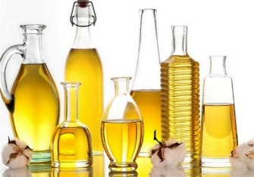f. Name 2 vegetarian choice for protein. Some vegetarian choices for protein are beans, chickpeas or lentils.

**6. Go to search and type in oil**

a. How do oils differ from solid fats? Oils are fats that are liquid at room temperature. While solid fats are solid at room temperature.

b. What types of fat should you avoid the most? The types of fat you should avoid the most are saturated fat and trans-fat.

c. Why is important to consume oils? Oils supply the body with essential fats and calories to absorb vitamins.

**7.**  **Go back to TOP menu and click Healthy Eating Style**

a. When selecting a beverage, what should you keep in mind? When selecting a beverage, you should keep in mind the amount of sodium, saturated fat, and added sugars in the beverage.

b. Name 5 small changes you would be comfortable implementing to have a healthier diet. Limiting sugars, limiting fats, eating more balanced meals, looking at nutritional values, and keeping track of what you eat.

**8. Go back to TOP menu and click on physical activity**

a. Two examples of moderate activity: Biking and dancing

b. Two examples of vigorous activity: Swimming and basketball

c. How much exercise should a teenager get every day? A teenager should get about an hour or more of physical activity every day.

d. How many calories are burned during 30 minutes of walking? ~140 calories

e. How many calories are burned when you swim for an hour? ~510 calories

f. Name 3 tips for increasing physical activity. Join physically active clubs, workout with friends or family and walk the dog.

**9. Reflection:** After learning about MyPlate, use the space below to evaluate your current diet. What are your strengths and weaknesses, what improvements do you need to make? Include all dietary aspects as well as physical activity when answering this question. Must have at least **10 different reflective statements** in complete sentences.

1. I should consume more fruits and vegetables per day.
2. I get around 45 minutes or more of exercise everyday through walking and biking.
3. I drink a bunch of water daily.
4. I should limit the amount of sugar I eat.
5. Also, it would be a good idea to limit the amount of fat I eat.
6. I should eat more protein.
7. I should get into a more balanced diet.
8. I should be more active with others, like friends and family, so it’s more fun and engaging.
9. I could consume more dairy products.
10. I should limit the amount of LDL foods I eat.